Boulder Dash Graphics
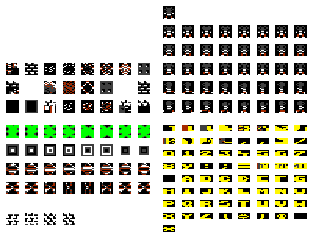
Here are the original C64 Boulder Dash object graphics. The colors vary a lot from cave to cave; here they are shown with the colors used in Cave A.
I have shown the full character set; be aware that there are some garbage characters in there. That's ok; you don't have a corrupt graphic.
I don't have the original BoulderDash title screen. The title screen in BoulderDash I is just made up of character graphics, so it should be pretty easy to mimic anyway, if you have a C64 lying around (I don't anymore, unfortunately). I definitely do not have the bitmap graphic of BoulderDash II, and that'd be really nice to have. Maybe someone else has grabbed it from a C64?

Martijn’s Boulder Dash Fan Site
Peter Broadribb

